April 1, 2020

Dear Chief and Council:
Re: Band Funds Application Package -
The Trust is a central depository of money held for the beneficiary Bands under the terms of the Trust Deed relating to settlement agreements with the Province of British Columbia and the Partnership. As such, all monies held in the Trust are held for the benefit of the beneficiaries. The Available Band Funds are provided for each Band to use at its discretion, provided its use complies with the terms as outlined in the Trust Deed. Consequently, the Trustees wish to encourage each Band to consider requesting funds for projects or events which will benefit their community.
Available Band Funds are pre-determined amounts allocated to each Band under the terms of the sharing formula. Your Band's allocated amount was included within the annual confirmation documents provided to your Chief and Council by e-mail. You may apply for such funding for eligible programs including a 10% administration fee up to a maximum of $50,000.00 per calendar year.
If you wish to access some of your Band Funds, please complete the following documents in order to facilitate the transfer:

- Band Funds Application Form - BFA – 2 Apr 1 20
- Band Council Resolution – BFA – 3 Apr 1 20

-2-
Once you have completed these items, please forward to:
Nlaka'pamux Legacy Trust (2013)
c/o Community Trustees
200 – 2000 West 12th Avenue
Vancouver, B.C. V6J 2G2
OR
e-mail: admintrustee@nlxlegacytrust.com

If you require any additional information regarding the Trust or the application process, please contact the Community Trustees,

Mark Podlasly 604-357-3326 e-mail mark@nlxlegacytrust.com
Ardith Walkem 604-858-7788 e-mail ardith@nlxlegacytrust.com
Norman Blain 250-453-9154 e-mail norm@nlxlegacytrust.com

Regards,
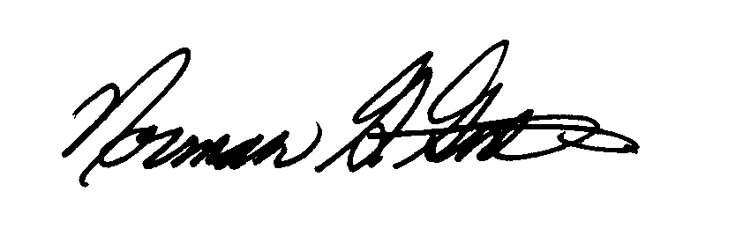
Norman G. Grdina
(In his capacity as Administrative Trustee)
Approved by the Community Trustees

T:\Trusts + Estates\NLAKA'PAMUX Legacy Trust (2013)\Approved Standard forms\Ardith Forms\new version\Band Fund BFA 1 Apr 1 20.docx

